CSS work

Menu table:

<!DOCTYPE html>

<html>

<head>

<title>Food Menu</title>

</head>

<body>

<fieldset style="background-color: burlywood; ;" >

<h1 align="center">Food Menu</h1>

<table align="center" cellspacing="20">

<tr>

<td align="center">

<a href="breakfast.html">

<img src="C:\top_technology\images\breckfast.jpg" alt="Breakfast" width="300" height="200"><br>

<b>Breakfast</b></a>

</td>

<td align="center">

<a href="lunch.html">

<img src="C:\top_technology\images\lunch.jpg" alt="Lunch" width="300" height="200"><br>

<b>Lunch</b>

</a>

</td>

<td align="center">

<a href="dinner.html">

<img src="C:\top_technology\images\dinner.jpeg" alt="Dinner" width="300" height="200"><br>

<b>Dinner</b>

</a>

</td>

</tr>

<tr>

<td align="center">

<a href="sandwich.html">

<img src= "C:\top_technology\images\sand.jpg" alt="Sandwich" width="300" height="200"><br>

<b>Sandwich</b>

</a>

</td>

<td align="center">

<a href="bakery.html">

<img src="C:\top_technology\images\bakery.jpg" alt="Bakery" width="300" height="200"><br>

<b>Bakery</b>

</a>

</td>

<td align="center">

<a href="beverages.html">

<img src="C:\top_technology\images\drink.jpg" width="300" height="200"><br>

<b>Beverages</b>

</a>

</td>

</tr>

</table>

</fieldset>

</body>

</html>

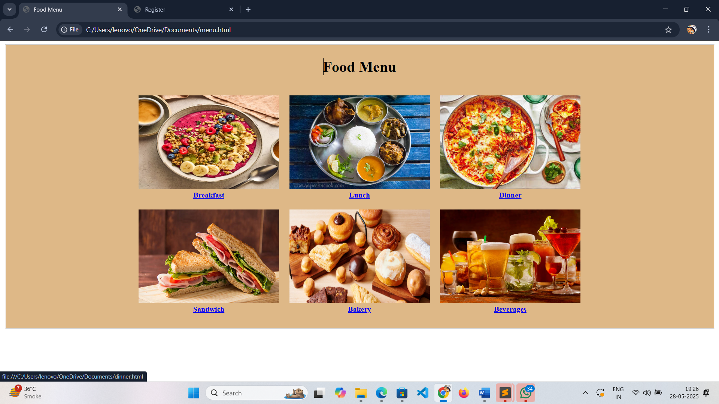

Image with table:

<html>

<head>

<title>

product catalog

</title>

<style>

.h1{text-align: center}

</style>

</head>

<body>

<h1 class="h1"> Product Catalog</h1>

<table border="1" cellpadding="10px" cellspacing="0px" align="center" style="background-color:bisque;">

<thead>

<tr style="background-color: whitesmoke;">

<th rowspan="2">product<br>Name</th>

<th rowspan="2">product<br>Image</th>

<th rowspan="2">Price</th>

<th rowspan="2" colspan="3">Description</th>

<th>Availability</th>

</tr>

</thead>

<tbody style="background-color: light-dark(, );">

<tr>

<td> Air Conditioners </td>

<td>

<a href="https://www.flipkart.com/air-conditioners/pr?sid=j9e,abm,c54">

<img src="C:\top_technology\images\key.jpg"width="100px" height="100px">

</a>

</td>

<td>50000rs</td>

<td colspan="3">An air conditioner (AC) is a system designed to cool down a space by removing heat and moisture from the air.</td>

<td > In Stock</td>

</tr>

<tr>

<td> Laptop</td>

<td>

<a href="https://www.lenovo.com/in/en/glossary/what-is-laptop/?srsltid=AfmBOorZkRRzGTy52wml2hL814_GSKGjraZ1XFJd5HxptqxWFNaZoXFu">

<img src="C:\top_technology\images\laptop.jpeg" width="100px" height="100px">

</a>

</td>

<td>45000rs</td>

<td colspan="3">A laptop, also known as a notebook computer, is a portable, personal computer designed for use on the go</td>

<td > Out of Stock</td>

</tr>

<tr>

<td> microwav oven</td>

<td>

<a href="http://www.flipkart.com/lg-20-l-i-wave-technology-health-plus-indian-cuisine-solo-microwave-oven/p/itmf3rygebb6pbk7?pid=MRCF2UQHF5FPDXGP&lid=LSTMRCF2UQHF5FPDXGPJIS1YS&marketplace=FLIPKART&cmpid=content_microwave-new_8965229628_gmc">

<img src="C:\top_technology\images\oven.jpeg" width="100px" height="100px">

</a>

</td>

<td>40000rs</td>

<td colspan="3">a kitchen appliance that cooks or heats food using electromagnetic radiation, specifically microwaves</td>

<td > In Stock</td>

</tr>

<tr>

<td> Sofa Set</td>

<td>

<a href="https://www.amazon.in/Caradel-Lewis-Seater-Living-Three/dp/B0CCLGZCQB?source=ps-sl-shoppingads-lpcontext&ref_=fplfs&psc=1&smid=A36FHCS5SCCFW7">

<img src="C:\top_technology\images\sofa.jpeg" width="100px" height="100px">

</a>

</td>

<td>35000rs</td>

<td colspan="3">Filling may be foam, down, or padding that is used to make the sofa comfortable. </td>

<td > Out of Stock</td>

</tr>

</tbody>

</table>

</body>

</html>

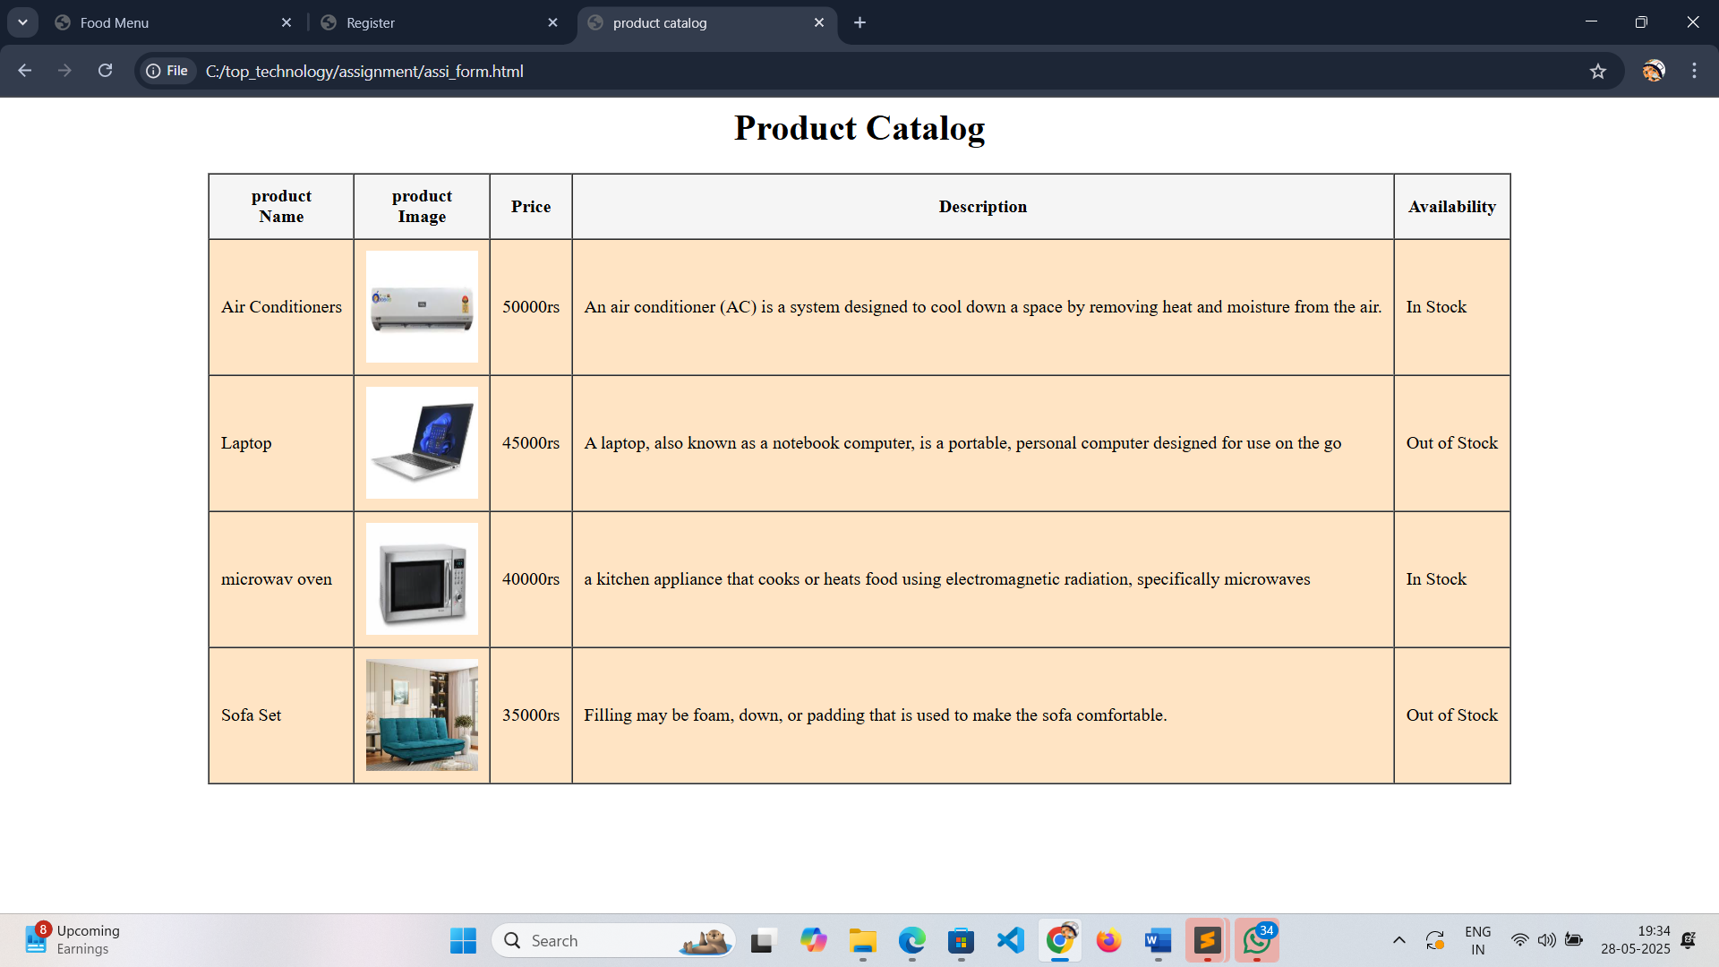

Sign up :

<html>

<head>

<title>Register</title>

</head>

<body>

<fieldset align="center" style="background-color: blanchedalmond;">

<h1 align="center"> Register </h1>

<form method="post" action="login.html">

<label>User Name: </label>

<input type="text" name="Name" minlength="10" maxlength="20"><br><br>

<label> Email: </label>

<input type="Email" name="Email" required><br><br>

<label>Password: </label>

<input type="Password" name="Password" required maxlength="12" minlength="8"><br><br>

<label>Confirm Password: </label>

<input type="Password" name="Confirm Password" required maxlength="12" minlength="8"><br><br>

<input type="button" name="Sign Up" value="Sign Up" style="background-color:blueviolet;"><br>

<h4> Have an Account?<a href="login.html">login Here </a></h4>

</form>

</fieldset>

</body>

</html>

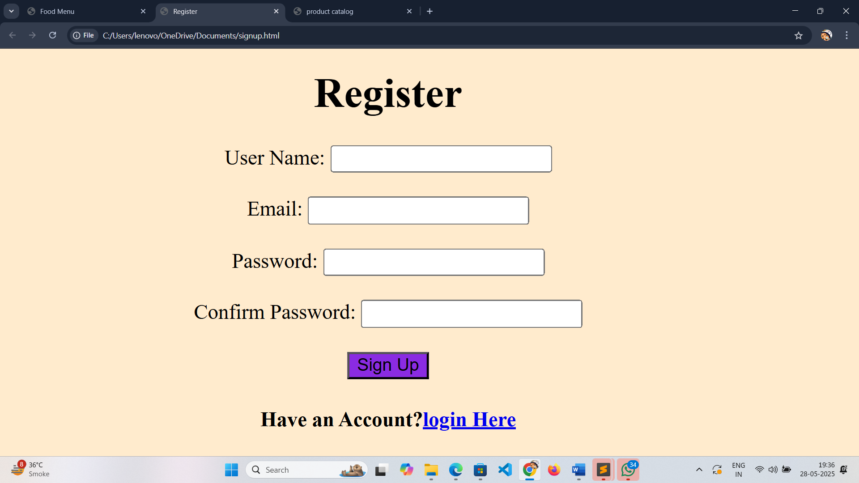

Login form

<html>

<head>

<title> Login </title>

</head>

<body>

<fieldset align="center" style="background-color:bisque;">

<form method="get" action="menu.html" style="background-color:bisque;">

<h1 align="center"> Login </h1>

<label>Email: </label>

<input type="Email" name="Email" placeholder="email"><br><br>

<label>Password: </label>

<input type="Password" name="Password" placeholder="Password"><br><br>

<input type="button" name="Sign In" value="Sign In" style="background-color: blue;">

<h4>Forgot <span>Email/Password</span>?</h4>

<h4> Don't have an account?<a href="signup.html">Sign up </a></h4>

</form>

</fieldset>

</body>

</html>

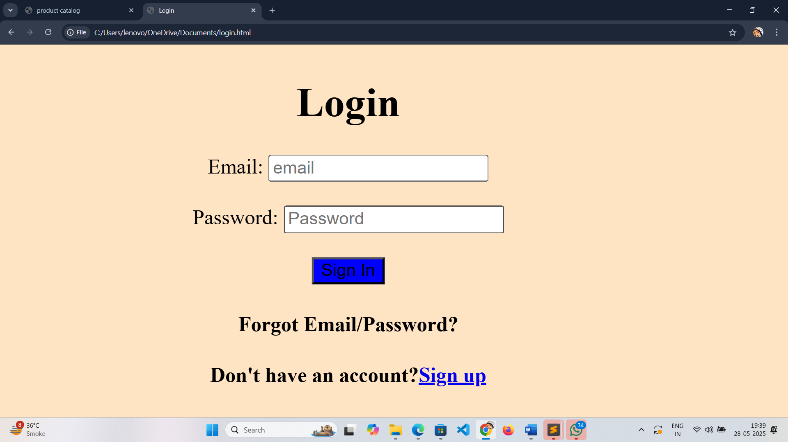

Contact us(get in touch) :

<html>

<head>

<title> Contact Us </title>

</head>

<body>

<fieldset align="center">

<form method="post" action="Contact Us" style="background-color:rosybrown;">

<h1 align="center">Get In Touch</h1>

<label>First Name:</label><br>

<input type="text" name="First Name"><br>

<label>Last Name:</label><br>

<input type="text" name="First Name"><br>

<label>Email:</label><br>

<input type="Email" name="Email"><br>

<label>Phone Number:</label><br>

<input type="Number" name="Contact"><br>

<label>What do you have in mind?</label><br>

<textarea name="What do you have in mind"></textarea><br><br>

<a href="https://www.instagram.com/accounts/login/?hl=en">

<img src="C:\Users\lenovo\OneDrive\Desktop\insta.jpeg" width="50px" height="50px">

</a>

<a href="https://www.facebook.com/login/">

<img src="C:\Users\lenovo\OneDrive\Desktop\fb.png" width="45px" height="45px">

</a><br><br>

<input type="submit" name="input" value="submit" style="background-color:blue;">

</form>

</fieldset>

</html>

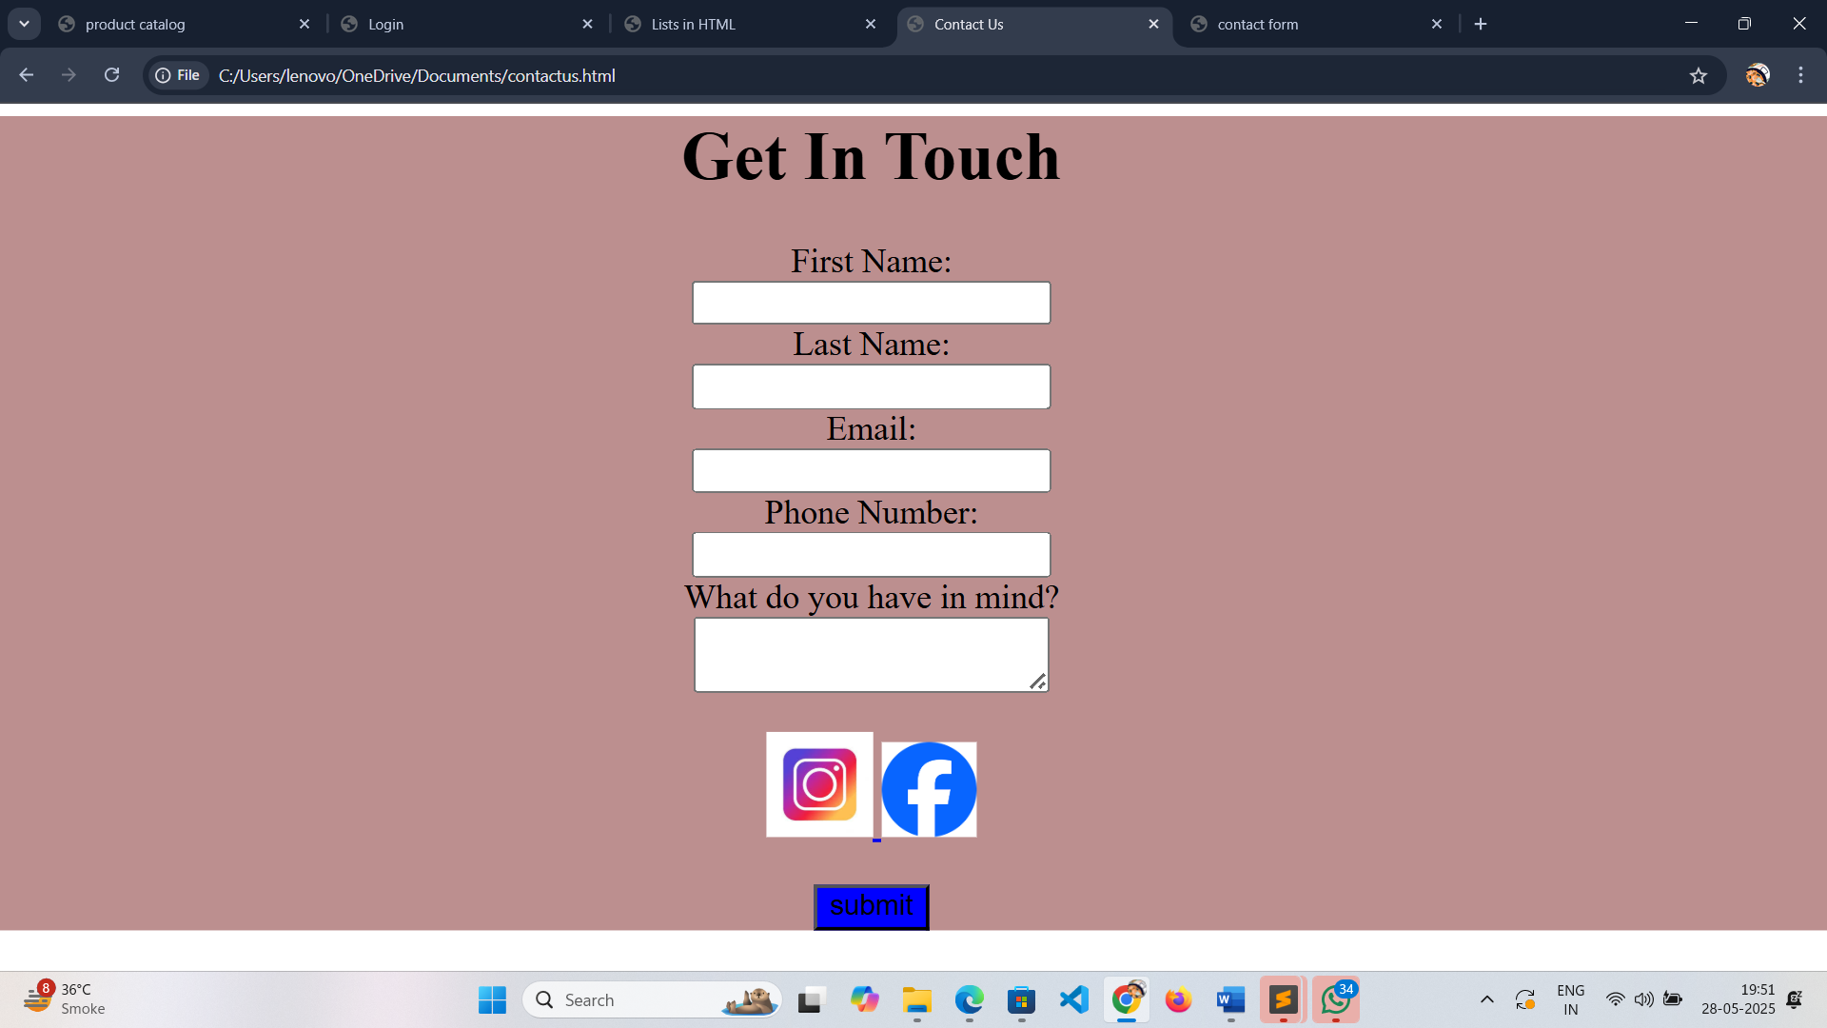

Contact us 2:

<html>

<head>

<title>contact form</title>

</head>

<body>

<fieldset align="center" style="background-color: yellowgreen;">

<h1 align="center"><mark>contact form</mark></h1>

<form method="post">

<label>first name:</label>

<input type="first name" name="first name"minlength="10" maxlength="10" pattern="[a-zA-Z]+" title=" add ALPHA "><br><br>

<label>middele name :</label>

<input type="text" name="middele name" minlength="10" maxlength="10" pattern="[a-zA-Z]+" title=" add ALPHA "><br><br>

<label> last name:</label>

<input type="text" name="last name" minlength="10" maxlength="10" pattern="[a-zA-Z]+" title=" add ALPHA "><br><br>

<label>Email</label>

<input type="Email" name="email" required><br><br>

<label>phone Number</label>

<input type="Number" name="contact" required pattern="[0-9]{10}" title=" add numbers only " placeholder="email"><br><br>

subject:

<select name="subject" required>

<option value="spam call"></option>

<option value="spam call">spam</option>

<option value="service call">service call</option>

<option value="banking call">baking call</option>

<option value=" sells call"> sells call</option>

<option value="feedback call">feedback call</option>

</select><br><br>

<label>message</label>

<textarea name="message" maxlength="30" minlength="20" ></textarea><br><br>

<input type="submit" name="submit" value="submit" style="background-color:burlywood;">

</textarea>

</form>

</fieldset>

</body>

</html>

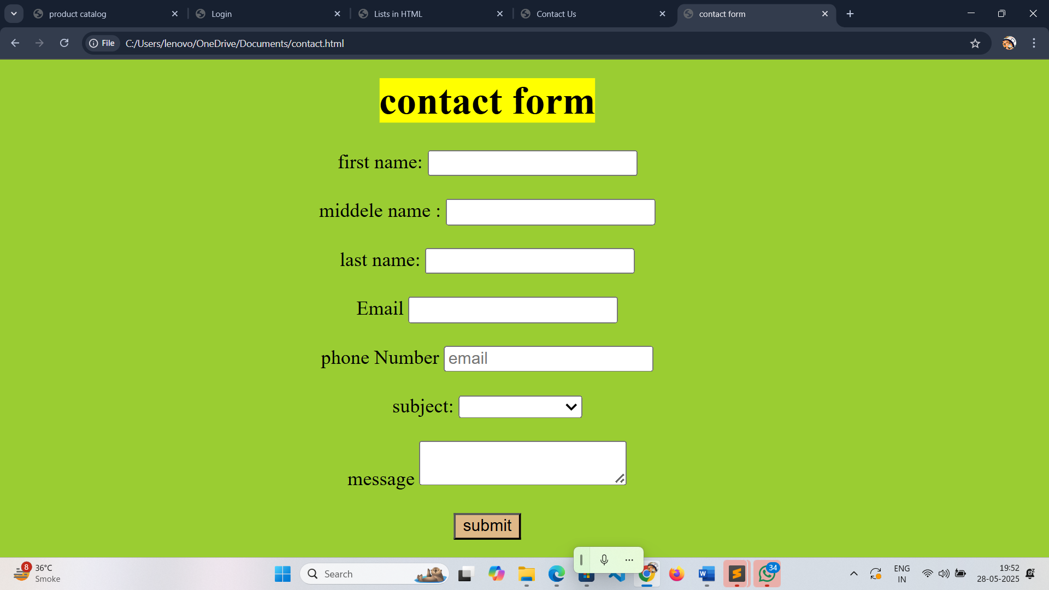

Info form:

<!DOCTYPE html>

<html>

<head>

<title>Lists in HTML</title>

</head>

<body>

<fieldset align="center" style="background-color:bisque;">

<h1 align="center"><b>Lists in HTML</b></h1>

<fieldset style="background-color: lightblue;style=width:33.33%;float:left;">

<div style ="width:33%;float: left";>

<h1 align="center">orderd list</h1>

<ol type="1" >

<li>Information Gathering</li>

<li>Planning</li>

<li>Design</li>

<li>Development</li>

<li>Testing & Deployment</li>

<li>Maintenance</li>

</ol>

</div>

</fieldset>

<fieldset style="background-color: rosybrown; style=width:33.33%;float:left;">

<div style="width: 50%;float:left";>

<h1 align="center">unordered list</h1>

<ul type="disc">

<li>HTML</li>

<li>CSS</li>

</ul>

<ul type="circle">

<li>SQL</li>

<li>PHP</li>

</ul>

<ul type="disc">

<li>JavaScript</li>

<li>Python</li>

</ul>

</div>

</fieldset>

<fieldset style="background-color:lightgrey; width:33.33%;float:left;">

<div style="width:50%;float:left">

<h2 align="center">Description List</h2>

<dl>

<dt><b>HTML</b></dt>

<dd>HTML stands for Hyper Text Markup Language.<br> HTML is the standard markup language for creating Web pages HTML describes the structure of a Web page.</dd>

<dt><b>CSS</b></dt>

<dd>CSS is the acronym of "Cascading Style Sheets".<br> CSS is the language used to style an HTML document. CSS describes how HTML elements should be displayed.</dd>

<dt><b>PHP</b></dt>

<p>PHP is an acronym for "PHP: Hypertext Preprocessor". PHP is a server scripting language, and,a powerful tool for making dynamic and interactive Web pages.</p>

</dl>

</div>

</fieldset>

</fieldset>

</body>

</html>

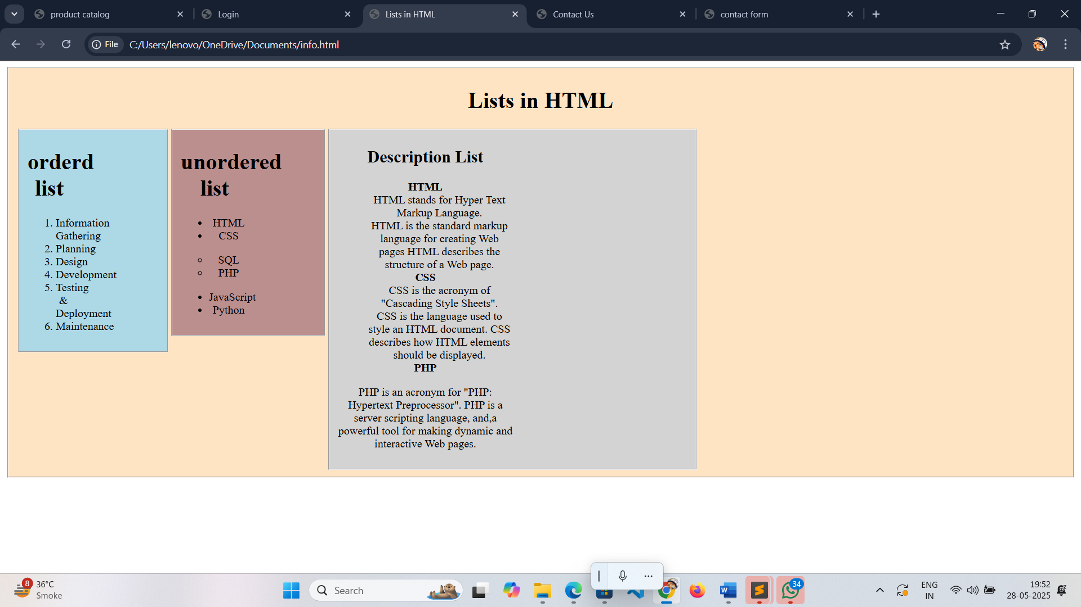

Feedback form:

+<html>

<head>

<title>feedback form</title>

</head>

<body>

<fieldset align="center" style="background-color: lightblue;">

<h1 align="center"> product feedback form with rules </h1>

<p>please rate the following aspects:</p>

<label> 1) Rate your overall satisfaction with the product</label><br>

Very Good: <input type="radio" name="satisfaction" value="very good">

Good: <input type="radio" name=" satisfaction" value="good">

Fair: <input type="radio" name="satisfaction" value="Fair">

Poor: <input type="radio" name="satisfaction" value="Poor">

Very Poor: <input type="radio" name="satisfaction" value="very poor"><br><br>

<label> 2) How easy was it to use the product?</label><br>

Very Good: <input type="radio" name="use" value="very good">

Good: <input type="radio" name=" use" value="good">

Fair: <input type="radio" name="use" value="Fair">

Poor: <input type="radio" name="use" value="Poor">

Very Poor: <input type="radio" name="use" value="very poor"><br><br>

<label> 3) How would you rate the performance of the product?</label><br>

Very Good: <input type="radio" name="performance" value="very good">

Good: <input type="radio" name="performance" value="good">

Fair: <input type="radio" name="performance" value="Fair">

Poor: <input type="radio" name="performance" value="Poor">

Very Poor: <input type="radio" name="performance" value="very poor"><br><br>

<label>Did you encounter any usability issues?</label><br>

Yes:<input type="radio" name="usability" value="Yes">

No:<input type="radio" name="usability" value="No"><br><br>

<label>were there any missing features that you expected?</label><br>

Yes:<input type="radio" name="missing" value="Yes">

No:<input type="radio" name="missing" value="No"><br><br>

<label>Did you experience any performance ussues?</label><br>

Yes:<input type="radio" name="performance" value="Yes">

No:<input type="radio" name="performance" value="No">

<h2> Thank you for taking the time to complete this <br> feedback form</h2>

<input type="button" name="submit" value="submit" style="background-color:blueviolet;">

</fieldset>

</body>

</html>

